SAFETY EXPERTS
Shop No. 4614-15 Gail Shahtara ,Ajmeri Gate Delhi -6
Ph.011-23215050,30114467,43517483
E-Mail -Rahulsakhuja@yahoo.com

AIR BREATHING APPARATUS
Resq two stage breathing apparatus is virtually maintenance free, durable , reliable and definitely the best value

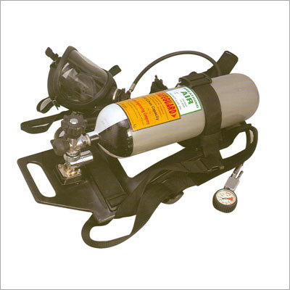
A Must of fire fighting operation & Industrial safety.
- Widely used all over the country by various private and public sector undertakings.
- Available in 30 minutes and 45 minutes duration cylinders.

SPECIAL FEATURES
- Pressure reduction systam of set is as per the latest international standards.
- No assistance required for donning the set.
- The cylinder can be charged for recharging without any difficulty.
- The brass parts are chromium plated for corrosion resistance.
- Gives audible alarm before the expiry of the time .
- The equipment is supplied in an easy to carry case.
- Incorporates many technological advanced designed to enhance long term reliability and achieve optimum performance with minimum supervision and maintenance.
Equipment Manufactured
Air Supply Cylinder : Seamless, high tensile steel cylinder manufactured to Home Office approved specification.
Cylinder Valve : Manufactured to BS/IS specification with a high tensile brass body and moulded rubber hand wheel.
Pressure Reducer : All brass construction utilising simple and well proven piston principle of operation and incorporating overload protection.
Air Hoses : Both high and low pressure hoses have stainless steel end fittings. Each hose is tested at more than twice its maximum working pressure.
Demand Valve : The demand valve operates in accordance with the wearer's inhalation and supplies air to the wearer's requirements. Exhalation is achieved through separate valve and when this takes place, the demand valve automatically closes.
Face Mask : Moulded rubber full face mask as reflex edges for perfect face seal having speech diaphragm & unidirectional exhalation valve quick release buckles for head harness provided.
Pressure Gauge : The easily readable pressure gauge calibrated in bars/PSI protected by rubber cover is connected to pressure reducer by a flexible high pressure hose line.
Cylinder Strap : The carrying cylinder strap of back plate can also accommodate cylinders of all types/sizes without any modification. The infinitely adjustable camlock mechanism provides a simple, very secure, quick and fail-safe operation.
Back Plate : Made of fibre glass, which is light in weight and has chemical resistance. It is orthopaedically designed in such a manner that weight of the cylinder is put on lower portion giving comfort to the user. For easy handling / transportation, a slot has also been provided on the back plate.
Alarm Whistle : Attached to high pressure attachment which is positioned close to the ear to avoid confusion as to where whistle is sounding, giving enough time to the user to reach safe place for change over of cylinders.
Harness Assembly : Made from fine quality nylon webbing is adjustable type with quick release buckles.
Operation manual and inspection procedure will be furnished with each set.
We can also offer you :
- Gas Mask Respirator
- Rope Ladder
- Safety Helmets
- Wind Sock
- Glow Signs
- Artificial Respirator
- Spark / Flame Arrester
- Safety Net, Safety Belt
- Barricading Safety Tape
- Fire Fighting Equipment
- Fire Suit

